* Design TM using simulator to accept the input string anbn

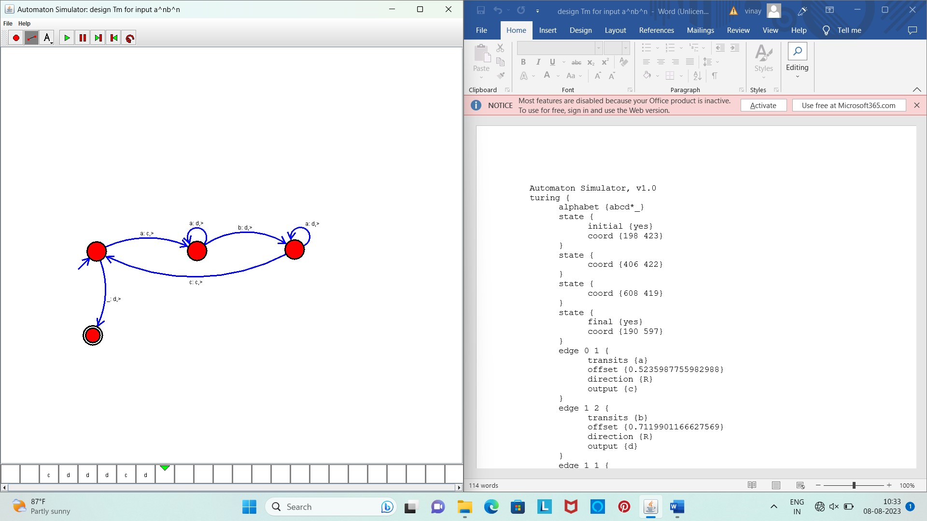

Result :

The simulator is accepted the given input string anbn  by using the above TM diagram.